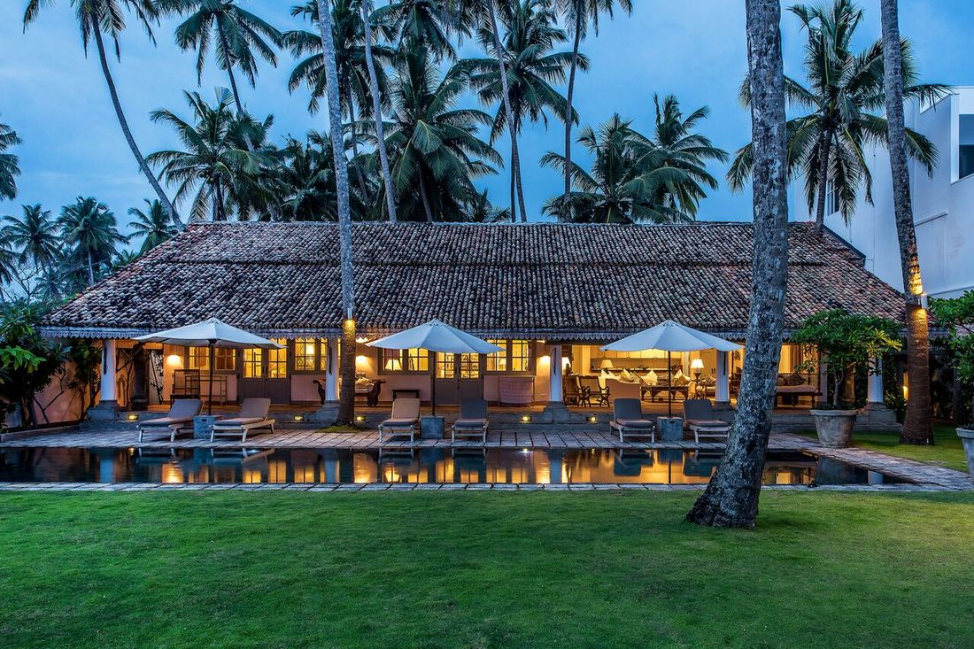

WELCOME TO SAMUDRA BEACH
1164/1 MATARA ROAD, HABARADUWA, GALLE, SRI LANKA, 80630

Welcome to our home. We have had so much pleasure creating this space and obviously want you to have a marvellous stay with us. We welcome any comments.

JANUARY 2024
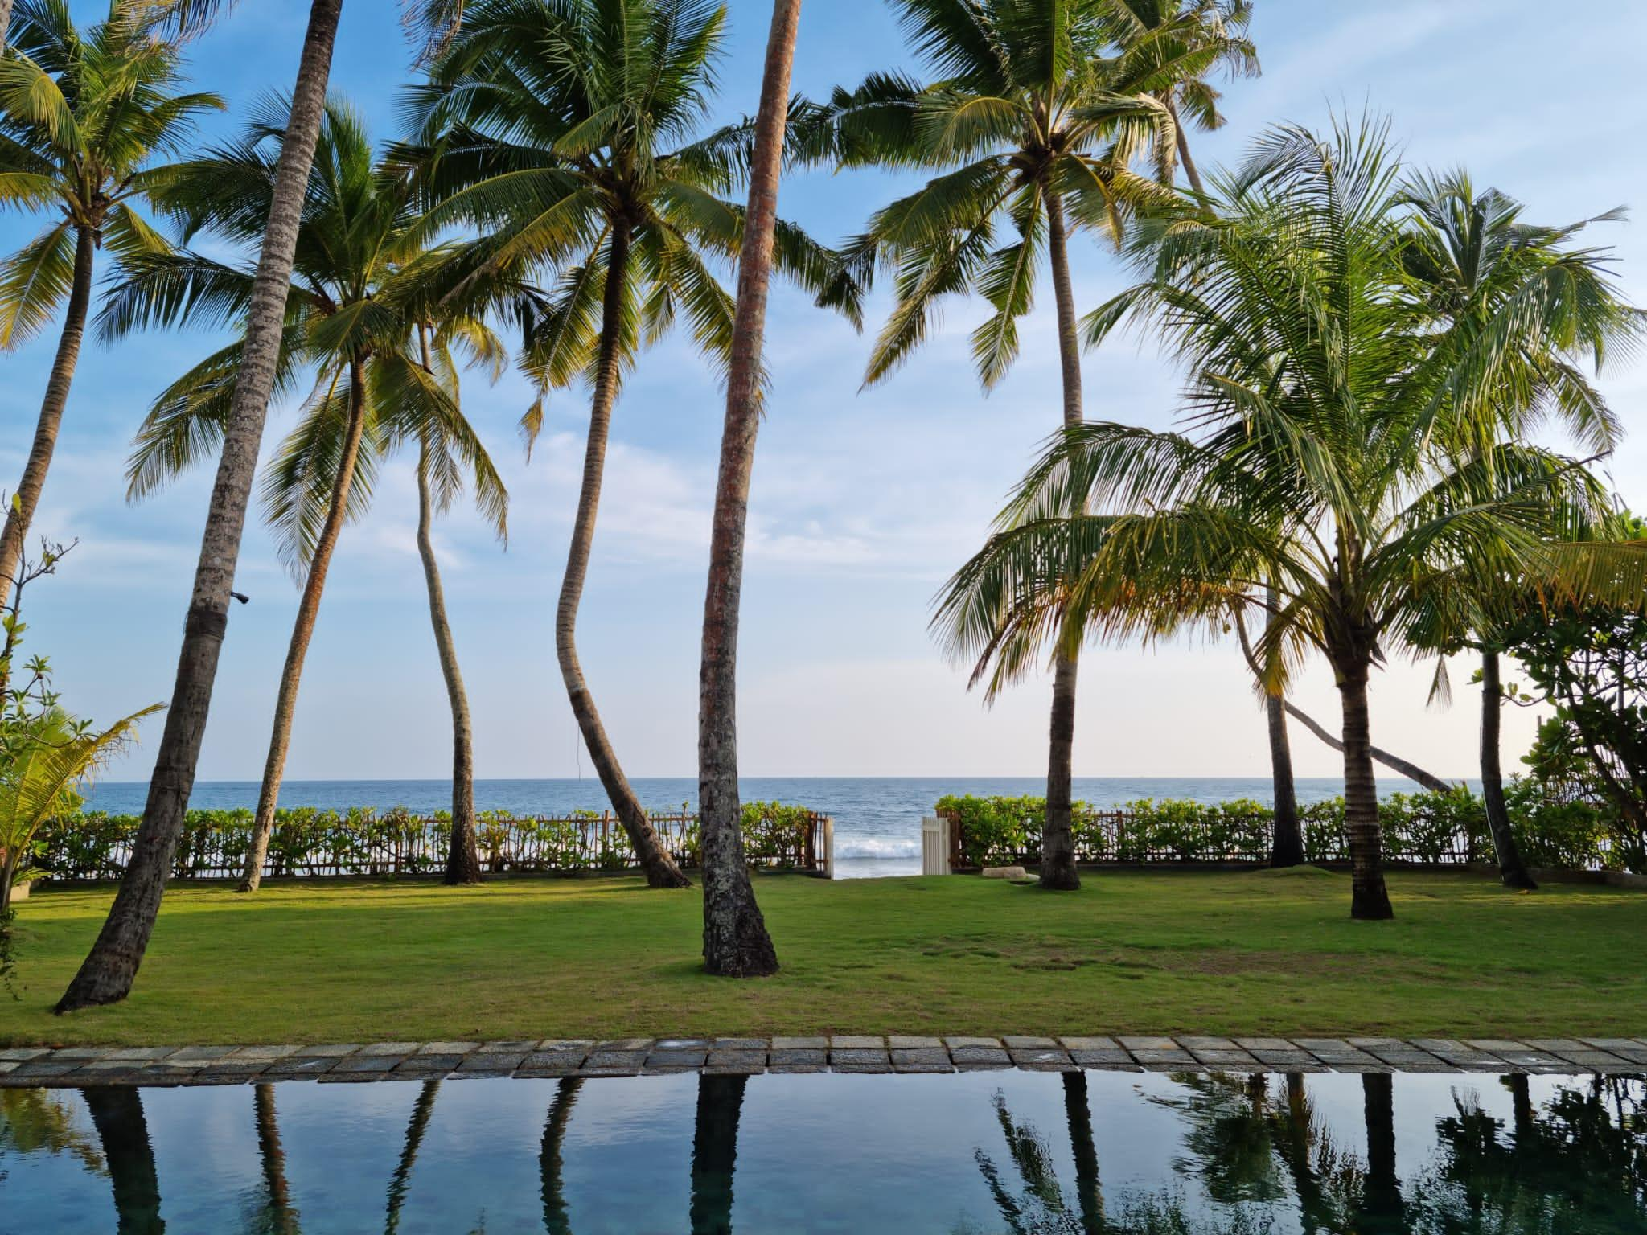
STAFF
Our staff are here to make your stay as comfortable and relaxing as possible. We hope you will leave with lasting memories of traditional Sri Lankan hospitality. If you do have any issues, please speak to -
Ruwan, House Manager. Tele no: +94 (0)772580419 or +94(0)789399165
Anne, Guest Services. Tele no: +94 (0)776498943.

OUR TEAM
Ruwan is our house manager and chef whose family lives in Matara.
He is an excellent cook and speaks pretty good English. He will prepare your breakfast as you wish and any other meals that you require. There is a suggested menu list but please feel free to ask for anything that you may like.
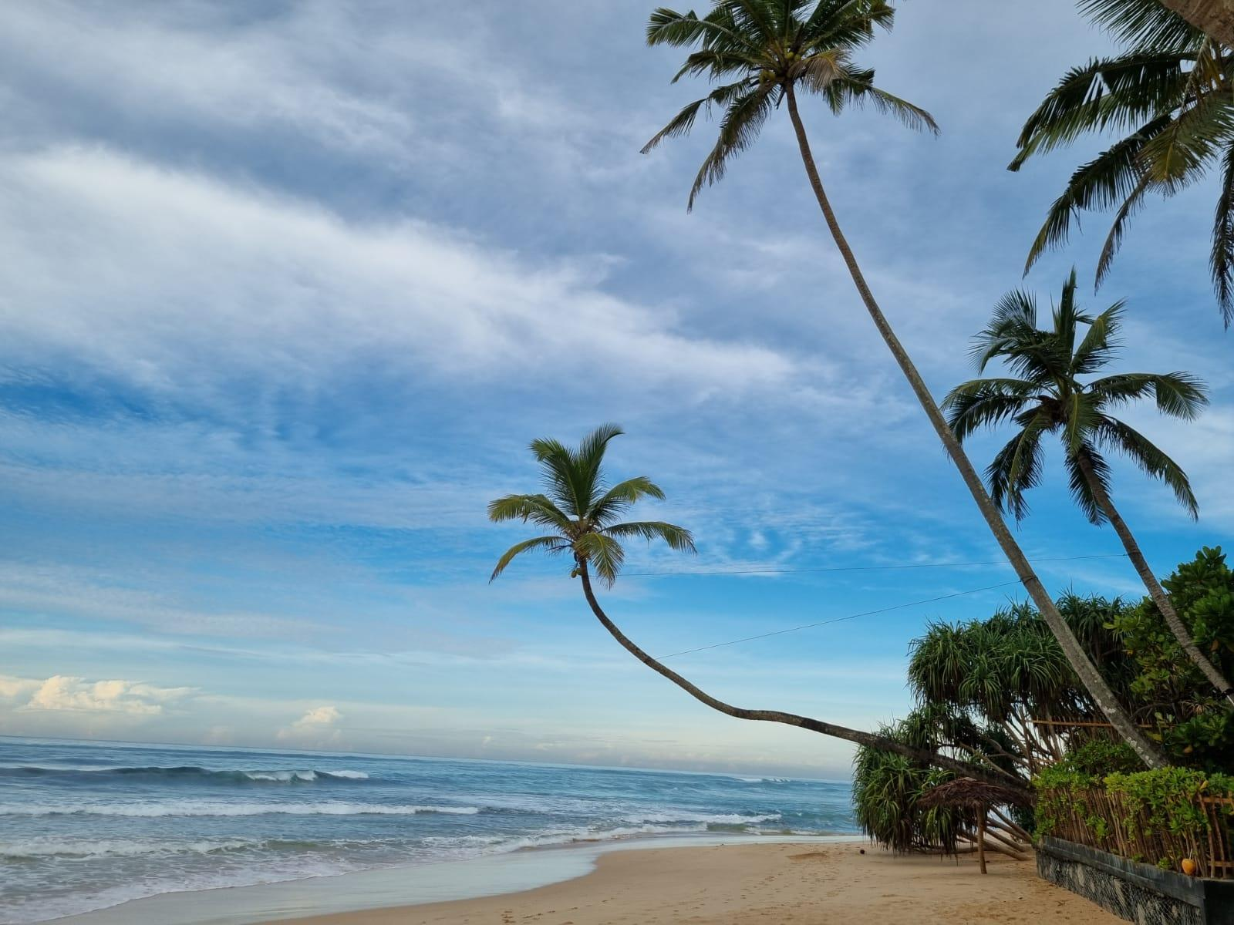
If you require him to cook lunch or dinner, then please do ask him after breakfast once you have planned your day. You are welcome to cook yourselves and he will happily do the shopping for you.
In terms of payment, he will ask you for a float and will bring you all the bills with no villa mark-up. He is extremely honest, in our experience, and you should have no problems here.
He or his team will be around for most of the day to look after you and the house, but we suggest that you set your own boundaries on how much you would like him around. He is quite shy and discrete.
Udara helps us to maintain the house and is very approachable. His English is not as good, so please speak slowly and make sure you are understood! He will make the beds and will tidy your rooms daily after breakfast duties are finished. If you need any extra towels or mosquito coils, etc., please ask him.
Both Ruwan and Udara have a scheduled 1 day off per week during the season, so feel free to arrange this with them.
Sunethra is our house lady. She can also help look after children during the day but has very little English.

SERVICE AND FACILITIES

ACCOUNTS
Ruwan will keep track of what he buys with your funds. Please ask for detailed accounts if you are not paying for things directly yourself in order to avoid any misunderstanding.

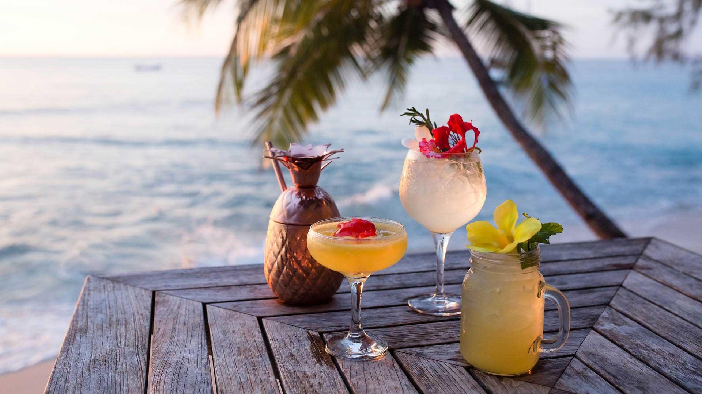
ALCOHOL
Bring your own by all means. There is a ‘local’ wine shop in Galle, Samagi Wines, which stocks a good selection of wines and spirits (but it is expensive and not very good). Another option is to buy the wine from Shiyani (House of Wines)–sales@houseofwines.lk. Delivers on a Friday. Another alternative is Supiri Wine in Matara (0412234447)- who also deliver.
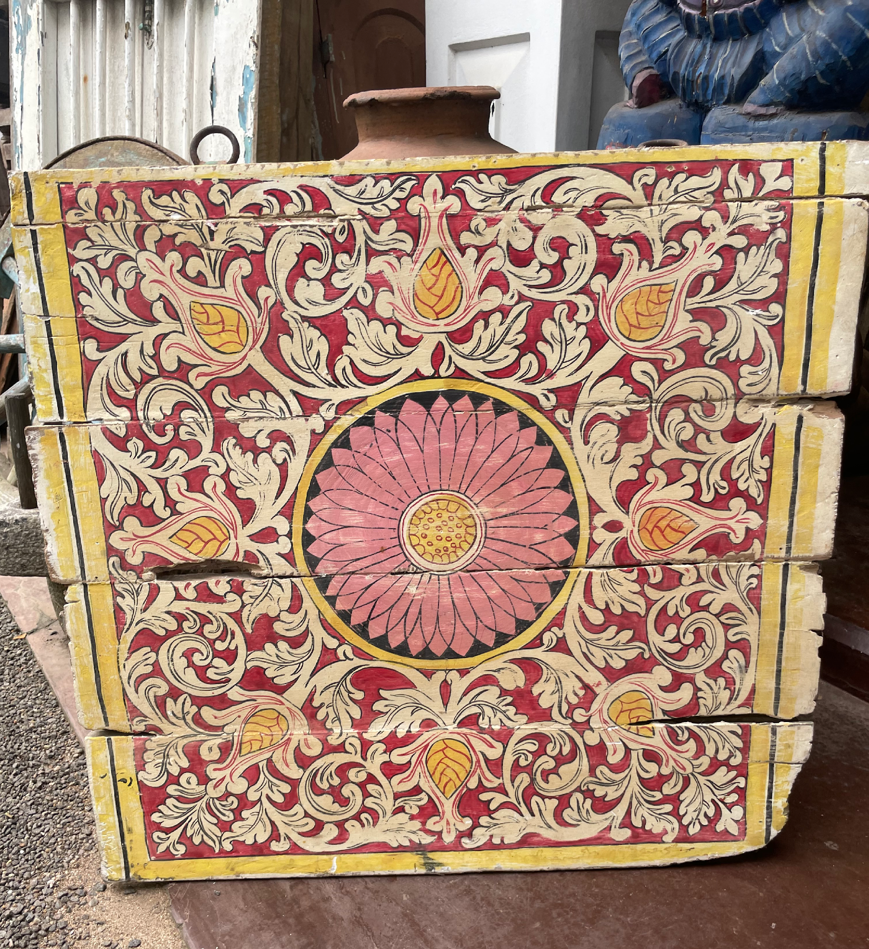
Do remember that no one will sell you alcohol on Poya Days (full moon days).

ANTIQUES
Our preferred shop is Ananda Antiques (about 10 minutes by Tuk Tuk).

BABYSITTING
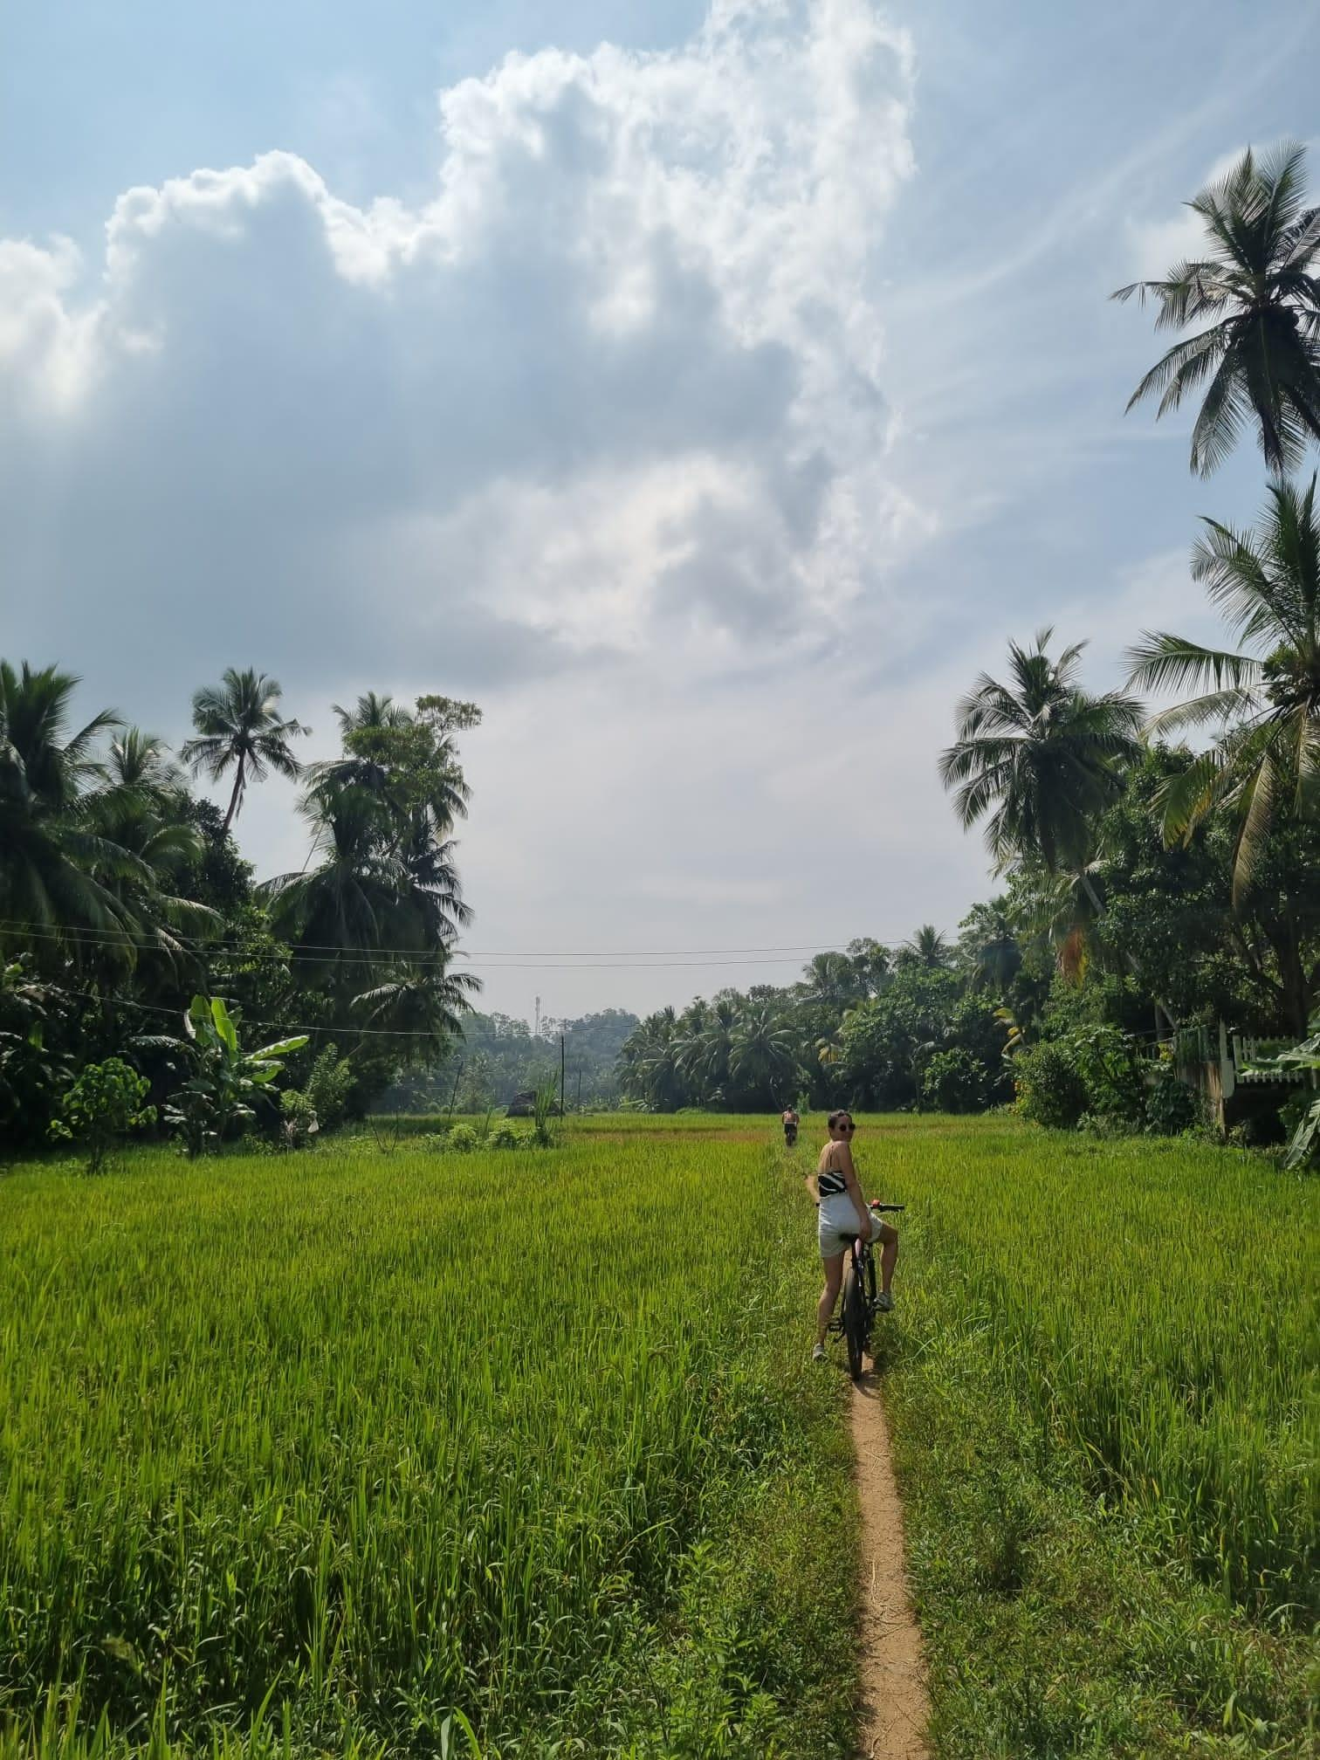
We regularly use babysitters who are available for 1500 RPS per hour. Nilanga is excellent and her number is +94 (0)768394105
BANKING
The local Sampath Bank, HSBC Bank and Commercial Bank of Ceylon all have ATMS. There is an ATM in Habaraduwa (5 minutes) – banking hours are 9am to 3pm. Ruwan can always change money for you.

BICYCLE TRIP
We recommend the plantation tour with Idle Tours. For more information, please see the box at Samudra for the guide. We recommend the plantation route not the lake route.Distances can be 10 k,15k or 25k.
BINOCULARS
Samudra has a very good pair.
BOOKS & GAMES
Please help yourself to books and games in the cupboard for use throughout your stay.
BREAKFAST
Continental breakfast is included.
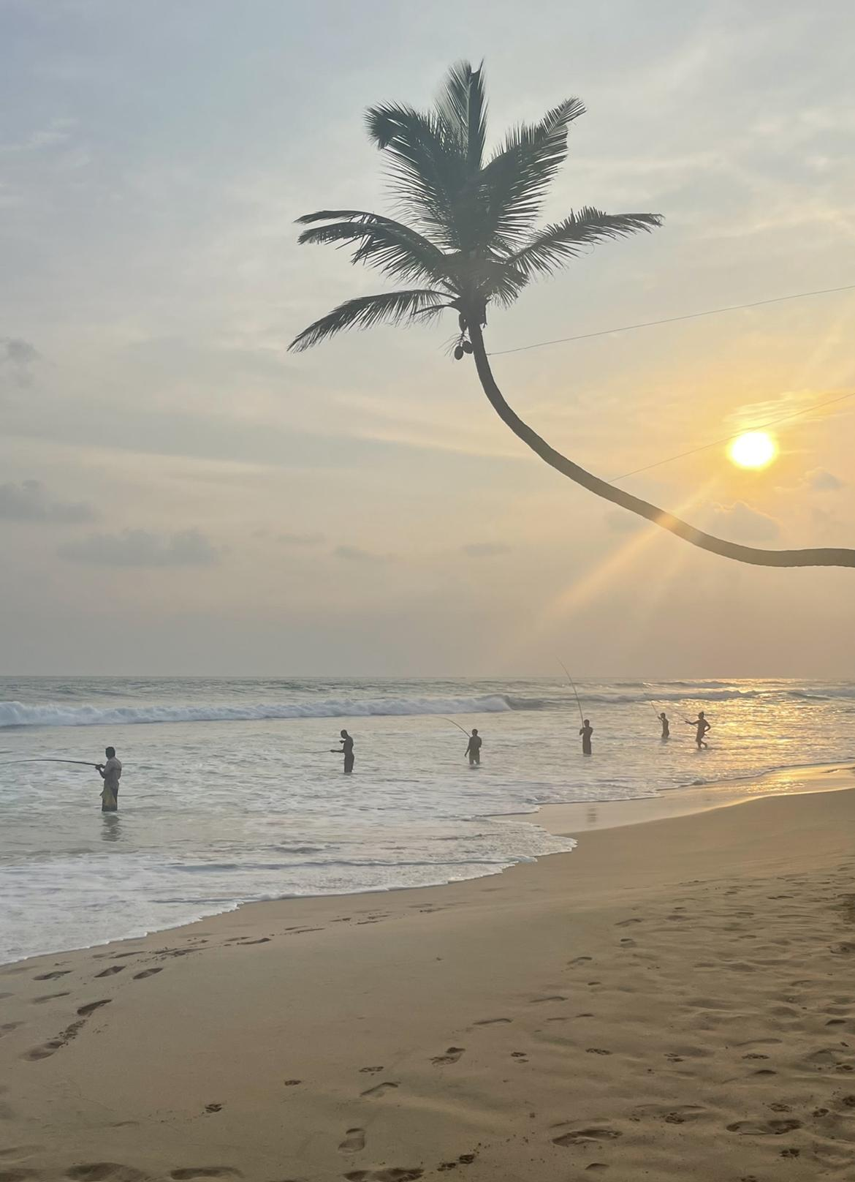
DRINKING WATER
Is readily available in the flagons provided. Any problems, please let us know.
ELECTRICITY
Is extremely expensive in Sri Lanka. Please be mindful of it and turn off the air conditioners that are the greediest! From time to time the electricity can be cut off for a number of hours in the day. We are sorry about this, but it is out of our control and should be covered by the newly installed generator.
In the High Season, electricity can be cut for one day in a week (around 9am-6pm). Ruwan will forewarn you. There is a power charger for you to use in the villa for iPads/iPhones etc.

FISHERMAN/COCONUT MAN
Once in a while, a fisherman tries to sell fish outside the gate. He is not a real fisherman so please do not buy the fish. There is also another guy who calls himself ,The Coconut man,he is harmless but a bit of a pain.
GYM
There is a personal trainer who can come to the house with equipment for $25 per hour. You can also access the gym at the Fortress hotel for $60, which gives you access to the pool and gym for the month and a discount of 10 percent of all food and drink bills.
LAUNDRY
Your sheets will be changed every three days and your towels daily, unless otherwise requested.
The white house towels are for your shower and the striped towels are for the pool and the beach.
Any personal clothes laundry can be sent to the local laundry or a full load of washing and ironing can be finished for 5,000 RPS per load.

MASSAGE
We recommend two male masseuses, Sampath +94717408494 and Kaseera +94 718348265 who can come to the house. Approximate price is 8,000 RPS for one hour. There is a lady masseuse, Prasanthi, who charges approximately 10,000 RPS. Again Ruwan can arrange.
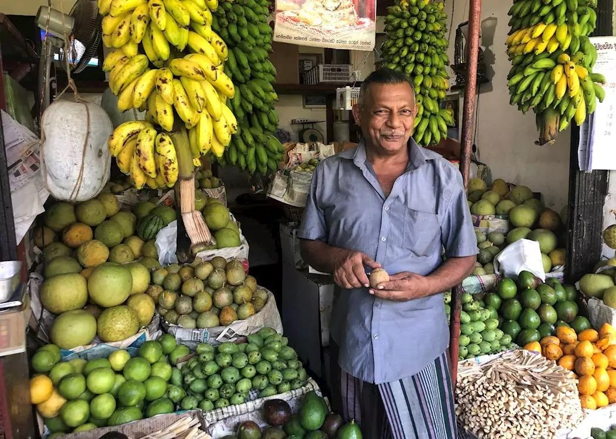
MEALS AND SHOPPING
We do a welcome shop so that there are the essentials on arrival. Ruwan will present you with this bill to be settled by you.
If you would like to go shopping with
Ruwan then just ask, and of course, if you have any special requests or dietary requirements do say so.
The local supermarket is Sea Fair and is close by. Keels on the Galle Road is in town on your way towards the Lighthouse Hotel. It is always worth checking the ‘sell by’ dates in any supermarket!
Please tell us about any allergies that you may have.

MEDICAL AID
We have a first aid kit in the cupboard near the fridge for minor things, and we ask Ruwan to check it. The Galle Hemas Hospital is close by and we have a good local doctor:
Dr De Silva can come at most hours of the day. Tel no: +94 (0)773036400 (he is expensive).
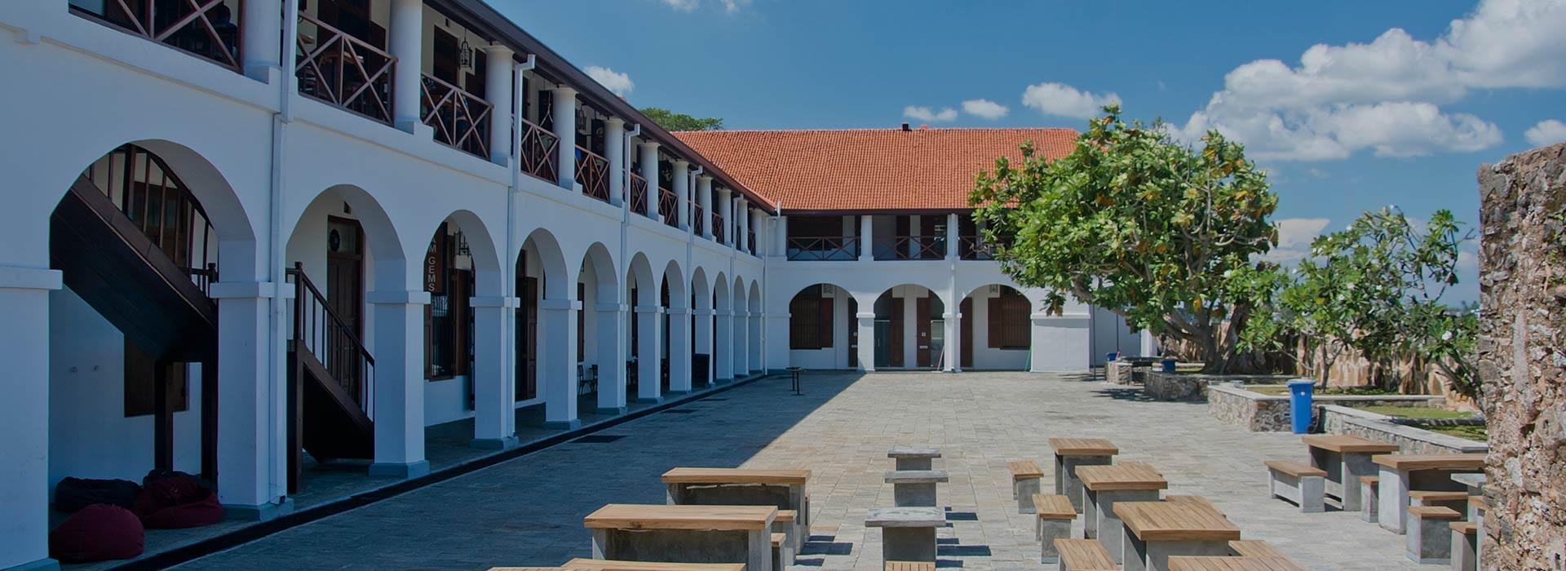
The best dentist is Nana Kara – tel no: +94 (0)777721550.

RESTAURANTS (Nearly all can be booked through Whatsapp)
Wine is quite expensive now between $30-60 - most restaurants can do a corkage fee $10-25.
ALAÏA, Goviyapana, Ahangama (20 minutes) - +94741040000. An amazing new hotel next to the Lighthouse. Homemade pasta and cocktails(can be a bit hit or miss). Sunset evenings with music, every Friday and Sundays (except POYA days).
Amangalla, 10 Church St, Galle (30 minutes) - Part of the Aman hotel group, they serve food in a colonial setting (one of the more expensive options). The Sri lankan curries are the best choice.Other food we find rather poor.
AQUA Forte, 62 Leyn Baan St, Galle (30 minutes) -+94-912231725 - Italian restaurant in the fort. Service can be quite slow but they have good pasta in a very good environment.
AQUA Pizza, 56 Leyn Baan St, Galle (30 minutes) - An authentic Italian pizzeria in the fort owned by AQUA Forte.
CITRA, Baranige Wattha, Welhengoda, Ahangama (20 minutes) -+94712148877 CITRA offers Ottolenghi style food with Mediterranean influences. In our opinion the best food in the area.
THE HIDEOUT, Yaddehimulla Rd, Unawatuna 80000 (20 minutes) - Mexican fusion food and great cocktails. Offers a taco tuesday each week.
KAIYO, Weligama (30 minutes) Excellent Japanese +94 (0)769838973 - you need to book. Definitely worth a visit.
K K On the beach – next door - nice for an ice cream.
La Boheme, 268/1 Matara Road, Godagewatta, Pellagoda, Unawatuna (15 minutes) - Homemade pizzas and pasta - nice atmosphere ,probably worth booking.
Love Gelato, 146 Devala Rd, Unawatuna (15 minutes) - The best ice cream outside of Italy!.
Lighthouse, Goviyapana, Ahangama (20 minutes) - An excellent spot for sundowners on the roof.
Palm Hotel, Nakanda, Galkadanduwa, Ahangama (20 minutes) - Nestled in the jungle, this is a good spot for brunch / lunch and to use the pool.
WB, Uyana Bandarawatta, A2, Unawatuna (10 minutes) - Great setting by the sea, serving Italian food. New owners.
Why House, Mihiripenna, Talpe (15 minutes) - Colonial setting, specialises in Thai, Lebanese, seafood and BBQ.
Wijaya Beach, Dalawella, Unawatuna (10 minutes) - A very popular beachside restaurant serving a mixture of Asian and European food. The beach is great for swimming with kids and you can often swim with the turtles.In High season it is very overcrowded on the beach. Excellent pizzas.
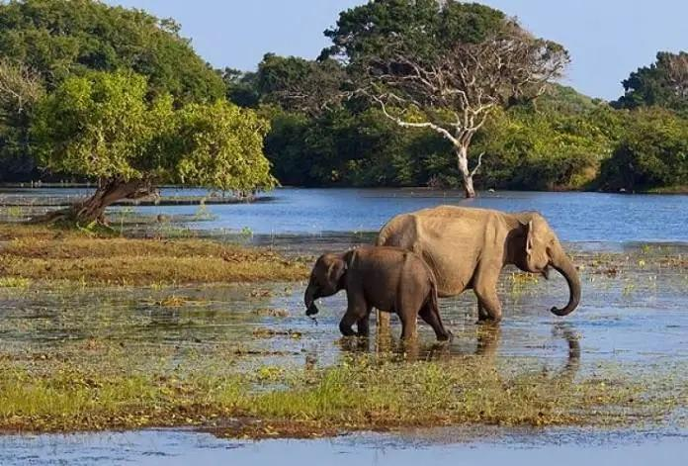
SAFARI
A marvellous day trip to Yala National Park or Udawalawa National Park. Home to wildlife such as leopards, elephants and crocodiles, as well as hundreds of bird species. There are overnight huts here but they are expensive.

Yala National Park – about 2 hours (transport about 32,000 RPS).
Udawalawa National Park – about 2 hours 30 minutes (transport about 25,000 RPS)
Ruwan can organise a package for any of these where the safari jeep is around 60,000 RPS on top
Best driver for day trips is Manjula (see transport). You can also camp at both locations at night. Manjula can arrange everything and is very safe and reliable.

SECURITY
Our night watchman is Pathmasiri and he comes on duty in the evening around 6pm until 6am in the morning. He is charming and helpful – but has very limited English.
SMOKING
Please can you refrain from smoking in the bedroom.

SHOPPING
Galle Fort – please see the guide in the box at Samudra.

SPA AND GYM
Kurulu Bay, Koggola Lake
The Fortress Hotel and Spa, Koggala, Habaraduwa, Galle
Okay Spa, Galle Fort
The Aman, Galle Fort
Spa treatments, Jetwing Lighthouse Galle
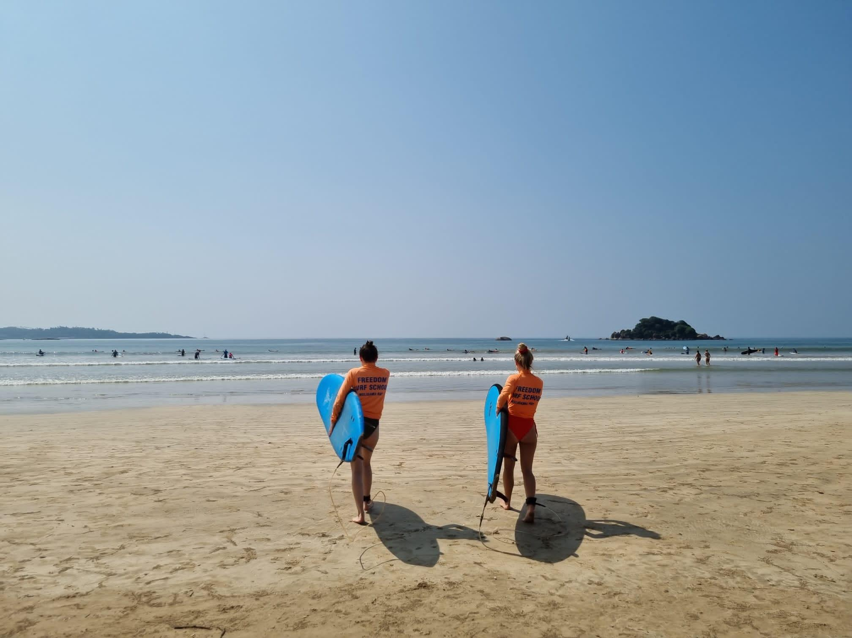
SURFING
Ahangama is about 15 minutes away. Weligama is about 20 minutes. Mirissa about 30 minutes. Boards can be hired. We normally use Weligama – the Freedom Surf School.

SWIMMING
The villa pool is cleaned daily. It is fairly deep with a steep step so please be careful.
Be very careful in the ocean always. Swimming is definitely seasonal and the sea can be very dangerous at times. We can take no responsibility. All swimming is at your own risk. If you wish to visit a different beach ask Ruwan and he can advise on some nearby options.

TENNIS
A court can be booked at the Lighthouse Hotel. Tel no: +94 (0)912224016.

TIPS
As a guide, if you feel inclined, we suggest in the region of 10% of your stay charge for the team. Totally voluntary and up to you. Either give directly to Ruwan or distribute individually.

TURTLES
Nest on the beach. Please do not touch the eggs. Turtles can be released back into the sea at the Turtle Farm (turn left out of the gate to the beach – about 300m). Large groups of turtles feed very close to Samudra – look out normally to the right by the white gate. Dolphins can also be seen if you are lucky. The Turtle Sanctuary owners can be quite aggressive and it is quite expensive.
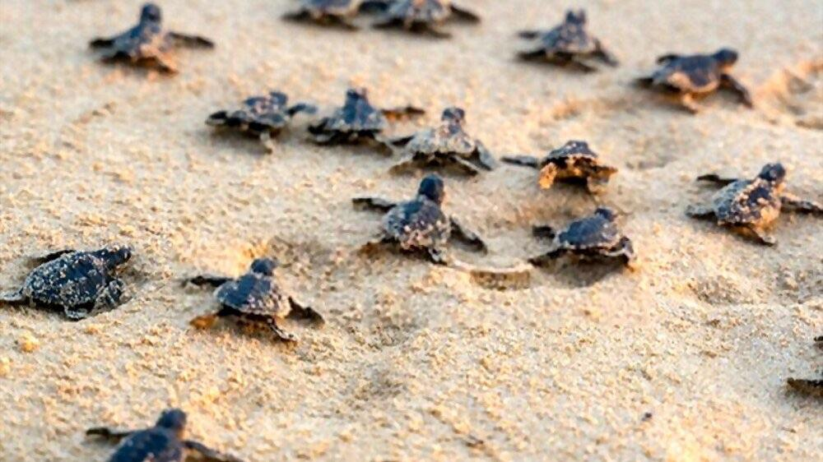

TV
Televisions in two rooms with access to Star channels. A Bluetooth speaker can be found in the main cupboard next to the books and games to be used for music.

TRANSPORT
There are always tuk tuks outside which are reliable and honest. It’s always best to ask Ruwan or Udara to arrange transport for you.
We use a driver called Samantha – rough guide to return rates including waiting are:
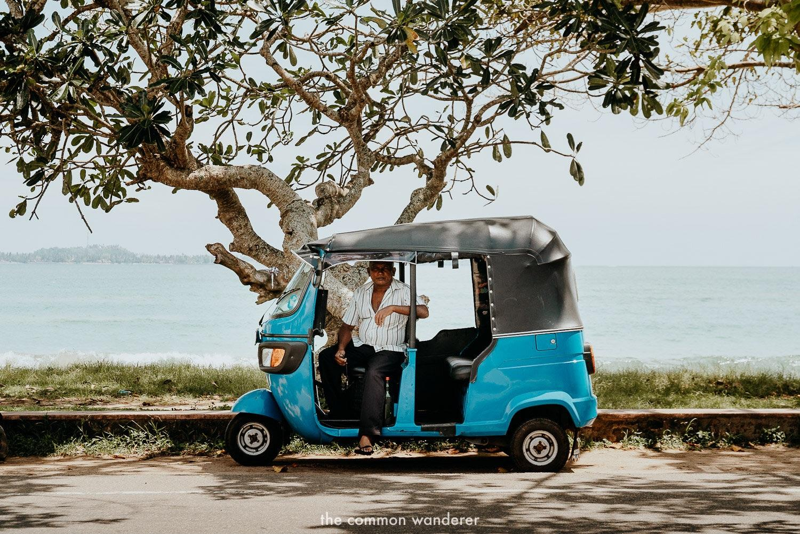
Ahangama – 3,200 RPS
Galle Fort – 4,000 RPS
Mirissa – 5,000 RPS
Unawatuna – 3,000 RPS
Weligama – 4,000 RSP
When you are going out for the evening it is advisable to arrange a drop off and a collection time so that you can be sure to get home as and when you want to, but most restaurants can also arrange.
If you need a small minibus which can hold up to about 6 pax, or do not like tuk tuks, we ring Sahan who lives next door on +94 (0)770302100. He charges about 8000 RPS to Galle Fort for the whole day. He can also be used for longer trips. Our preferred driver for trips to safaris/tea plantations etc is Manjula +94 (0)773628685 or manjula_kumara@hotmail.com. Exceptionally reliable and knowledgeable. Airport transfers are about 35,000 RPS.

VALUABLES
We have a safe in the cupboard in the living room. Use it! Always wise not to leave things visible.

VENTURING OUT
Galle Fort (30 minutes by tuk tuk) is fascinating to explore for its architectural interest and daily life within its walls. Little has changed over the years, occasionally touts will badger you, but simply say nicely ‘epa’ which means ‘no need’ in a polite way!
Do dress accordingly – ladies, cover your shoulders and not too short shorts! It is a Muslim quarter and respect is appreciated by all who live there.

WHALES AND DOLPHINS
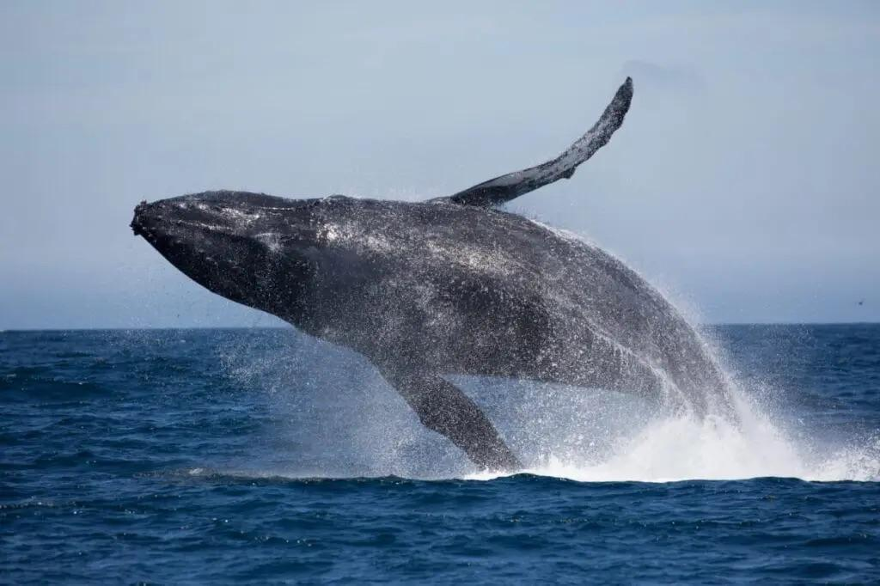
Early morning trip – about 2 hours out to sea between November – April. Amazing.
Boats leave from Mirissa (about 40 minutes). The trips start at about 7am and the duration of the tour is about 3-4 hours. The companies provide water and a sandwich. 20,000 RPS per person on a boat.

There is a private boat (seats 4) – faster and around 120,000- 180,000 RPS for a luxury experience. 7.00 am - 1.00pm.On top of this price one has to pay 6,000 RPS for a Wildlife ticket per person.

WI-FI
The password for the main house and poolside (UN: Samudra beach) is samudra123
The wifi password in the upstairs bedroom (UN: Samudra villa1) is samudra1234

YOGA
We can ask Kaseera to come to the villa to run private sessions. He charges 5000 RPS per hour +94 (0) 718348265 or there is Eva based at Wijaya +94 (0)773002802.
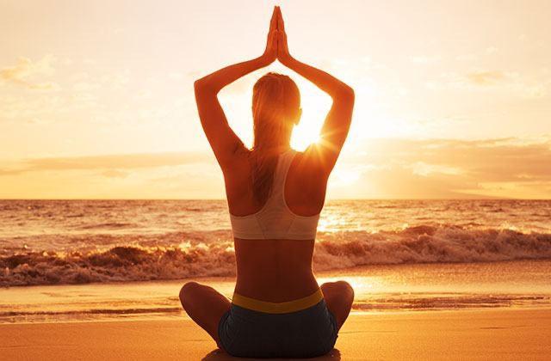
The most popular place for drop in daily yoga sessions is Sri Yoga, located in the jungle nearby (10 minutes drive). Check the times via their website - https://www.sriyogashala.com/
The yoga is excellent in a wonderful setting. Costs:
- Drop-in – 3,700 RPS (cash only)
- 10 x class – 25,000 RPS (cash only).
Best to check times at start of the stay

AND FINALLY….

THANK YOU FOR STAYING WITH US!
We welcome your feedback –
Please do not forget to sign our guest book before leaving.

